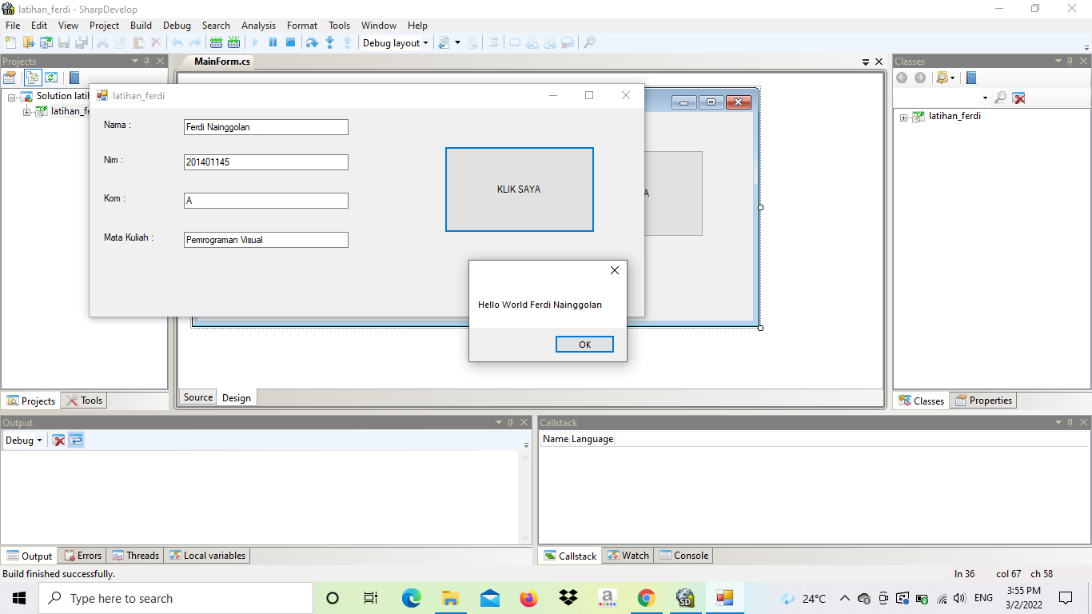

/*  
 * Created by SharpDevelop.  
 * User: FERDI NAINGGOLAN  
 * Date: 3/2/2022  
 * Time: 3:42 PM  
 *   
 * To change this template use Tools | Options | Coding | Edit Standard Headers.  
 */  
**using** System;  
**using** System.Collections.Generic;  
**using** System.Drawing;  
**using** System.Windows.Forms;  
  
**namespace** latihan_ferdi  
{  
    /// <**summary**>  
    /// Description of MainForm.  
    /// <**/summary**>  
    **public** partial class MainForm : Form  
    {  
        **public** **MainForm**()  
        {  
            //  
            // The InitializeComponent() call is required for Windows Forms designer support.  
            //  
            **InitializeComponent**();  
              
            //  
            // **TODO**: Add constructor code after the InitializeComponent() call.  
            //  
        }  
              
          
        void **Button1Click**(object sender, EventArgs e)  
        {  
            MessageBox.**Show**  ("Hello World " +**this**.textBox1.Text);  
        }  
    }  
}

